Pokhara University

Level: Bachelor | Semester – Spring | Year : 2006
Programme: BE |  | Full Marks: 100
Course: Network Theory |  | Time : 3hrs.

Candidates are required to give their answers in their own words as far as practicable.
The figures in the margin indicate full marks.

Attempt all the questions.

 | - A series circuit containing R = 7 Ω, L = 1H and C = 0.1F is connected to 20 V dc supply at t = 0 Sec. Find the expression of voltage across capacitor at any time using classical method considering inductor and capacitor initially inert.  - Find the complete expression of current through 20 Ω resistor using classical method.  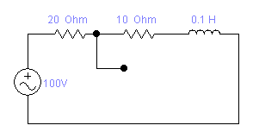  t =0  +  ––  –  –– | 8  7
 | - Find 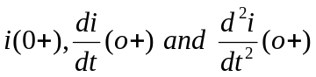 for the given circuit. Assume no initial energy storage and the switch is closed at t = 0 sec.  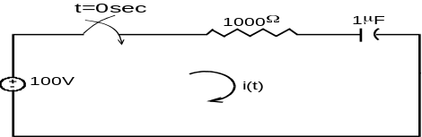  - An exponential supply 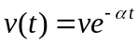 is suddenly applied to a series circuit containing resistor R and inductor L. Find the expression of i(t) at any time using classical method. | 7  8
 | - Point out some advantages of Laplace transformation method for solving differential equations over the classical method.  - Using Laplace transformation technique solve the following differential equation: 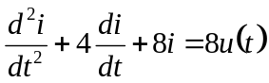. Given that i(o+) = 3 and i/(o+) = – 4  - What is convolution integral? Explain the mathematical process of convolution integral theorem. | 5  5  5
 | - Find V_{2(s)} / V_{1(s)} for the following network.  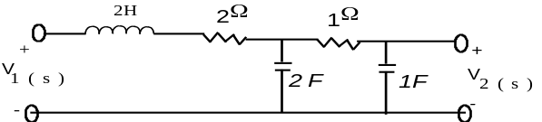  - Obtain the trigonometric form of the Fourier series for the following function.  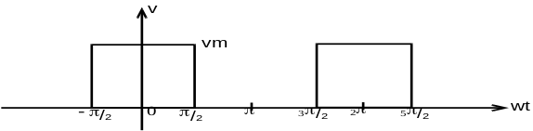 | 7  8
 | - Plot the straight line asymptotic magnitude response. 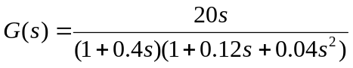  - Determine whether the following is a positive real function: 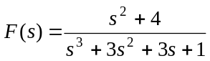 | 8  7
 | - Using Foster second form synthesize the following function: 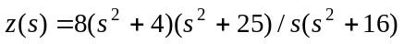  - Find z parameters for the following network.  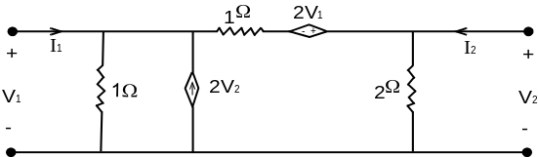 | 7  8
 | Write short notes on (Any Two):  - Time constant of RC series circuit  - Ideal and non ideal Filters  - Properties of RL impedance function | 5×2

